Subject Line: Magellan Bulletin - January 2022 Momentum Engagement Campaign and Webinars
Email content is below.

Monthly Theme
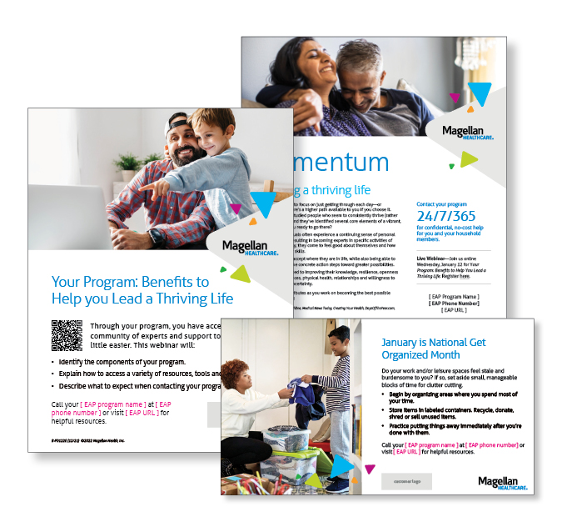
Building a thriving life
While it’s common to focus on just getting through each day—or basic survival—there’s a higher path available to you if you choose it. Researchers have studied people who seem to consistently thrive (rather than just survive) and they’ve identified several core elements of a vibrant, healthy life. Learn more in this month’s newsletter.

Monthly Webinar
Your Program: Benefits to Help You Lead a Thriving Life | January 12
Join this webinar to:
- Identify the components of your program.
- Explain how to access a variety of resources, tools and services.
- Describe what to expect when contacting your program.
Click Here to Register

Financial Wellness Monthly Webinars
New Year...New You! Financial Resolutions You Can Keep | January 11
Register here: 9 am PT | 12 pm PT
When January arrives, many of us want to start a new financial habit or break a bad one. The real challenge isn’t getting started but sticking to the plan. As a financial coaching organization, we have worked with thousands of people to help them stick to their New Year’s resolutions. We will share tips for setting realistic goals and making it to the finish line.

It’s My Budget & I’m Sticking to It! | January 27
Register here: 9 am PT | 12 pm PT
Creating and sticking to a budget is the foundation for great personal finances. Why? It gets you in the habit of reviewing and adjusting your spending so that the most important goals in your life get funded. This class will outline a process for creating a spending plan and will offer practical tips for sticking to it!

