Subject Line: Magellan Bulletin - February 2022 Momentum Engagement Campaign and Webinars
Email content is below.

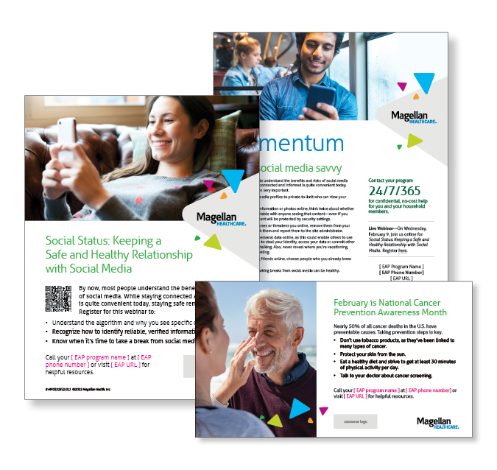
Monthly Theme
Becoming social media savvy
By now, most people understand the benefits and risks of social media use. While staying connected and informed is quite convenient today, staying safe remains very important. Learn more in this month’s newsletter.

Monthly Webinar
Social Status: Keeping a Safe and Healthy Relationship with Social Media | February 9
Join this webinar to:
- Explain the algorithm and why you see specific content.
- Recognize how to identify reliable, verified information.
- Know when it’s time to take a break from social media.
Register here

Financial Wellness Monthly Webinars
Understanding Tax Returns | February 8
Register here: 9 am PT | 12 pm PT
For most of us, tax season can mean only one thing, “How much is my refund?” But before we get to the good part, a lot needs to be discussed in terms of how income tax is calculated, types of adjustments/deductions, ways to reduce taxation, and strategies to save. We will also review any tax law changes and explore some common mistakes that could be avoided with proper planning.

Social Security & Your Retirement Plan | February 24
Register here: 9 am PT | 12 pm PT
We contribute to the Social Security system through payroll deductions throughout our lives, but don’t always know our best options for receiving those distributions after retirement. In this presentation, we discuss how benefits are calculated and how to determine when to start receiving distributions in retirement. We will also talk about spousal benefits, as well as factors that may influence whether you are taxed on the distributions you receive.

