**Subject Line:** Magellan Bulletin - May 2022 Momentum Engagement Campaign and Webinars

**Email content is below.**

**Monthly Theme**

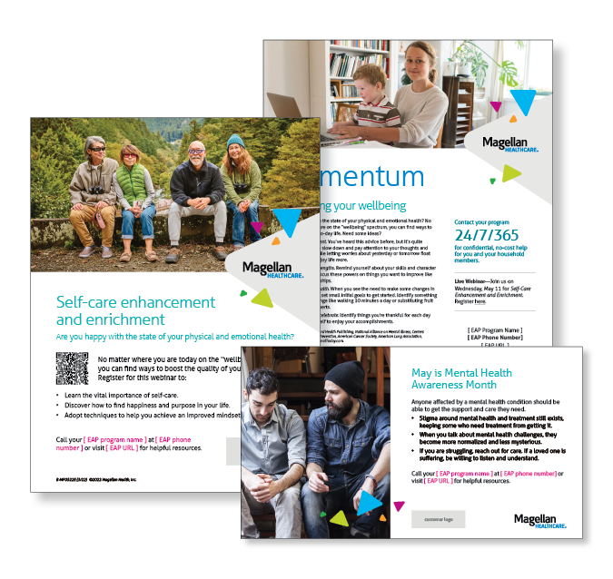**Enhancing your wellbeing**

Are you happy with the state of your physical and emotional health? No matter where you are on the “wellbeing” spectrum, you can find ways to improve your day-to-day life. Need some ideas? Learn more in this month’s newsletter.

**Monthly Webinar**

**Self-Care Enhancement and Enrichment | May 11**

Join this webinar to:

* Explain the importance of self-care.
* Describe how to find happiness and purpose in life.
* Develop techniques to achieve an improved mindset and mood.

[**Register here**](http://magellanhealth.adobeconnect.com/ej0w9sd5xvqt/event/registration.html)

**Financial Wellness Monthly Webinars**

**I Want to Buy a House | May 10**

Register here: [9 am PT](https://mysecureadvantage.zoom.us/webinar/register/1116358764594/WN_QGkoIH5vRT-sqifYCPSDBQ) | [12 pm PT](https://mysecureadvantage.zoom.us/webinar/register/2516358784113/WN_q5hIxuZDQcqCUH8NySTCKA)

Buying a home can be an achievable goal if you do your research and plan for all the expenses associated with both purchasing and maintaining a home. We’ll walk you through the different types of mortgage loans, review what lenders are looking for, and what costs you can expect from the closing process. With proper planning, your home can bring you joy for years to come!

**Protecting Your Assets with Insurance | May 26**

Register here: [9 am PT](https://mysecureadvantage.zoom.us/webinar/register/5616358788600/WN_wPuqGTcPTQWyQmIVW-bI-Q) | [12 pm PT](https://mysecureadvantage.zoom.us/webinar/register/7816358793163/WN_BnB9UWfUQPqHEmVFfhv-4Q)

Insurance is more than just a safety net. It’s part of your overall financial strategy! In this class, we explain the importance of vehicle, property, life and other common forms of insurance. Our goal is to equip you with the information you need to assess the right coverage for your life and assets. We will also share some tips and best practices for shopping around and getting the best rates.