**Subject Line:** Magellan Bulletin - June 2022 Momentum Engagement Campaign and Webinars

**Email content is below.**

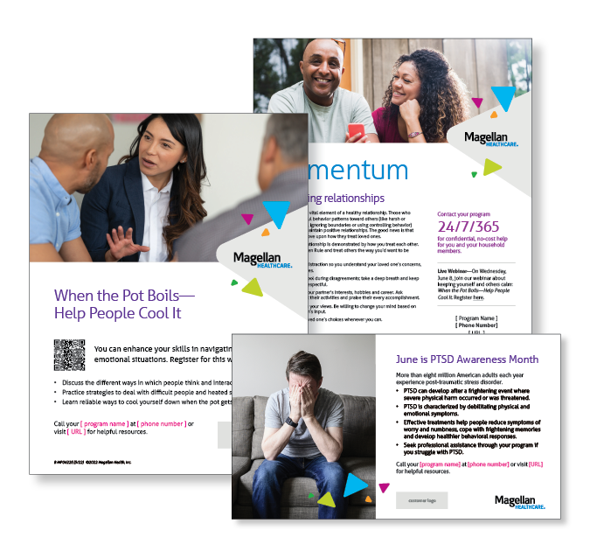**Monthly Theme – Employees**

**Respecting relationships**

Mutual respect is a vital element of a healthy relationship. Those who exhibit disrespectful behavior patterns toward others (like harsh or belittling language, ignoring boundaries or using controlling behavior) often struggle to maintain positive relationships. The good news is that everyone can improve upon how they treat loved ones. Learn more in this month’s newsletter.

**Monthly Webinar – Employees**

**When the Pot Boils—Help People Cool It | June 8**

Join this webinar to:

* Describe different ways people interact and how people think.
* Practice strategies to deal with difficult people and heated situations.
* Recognize ways to cool yourself down.

[**Register here**](http://magellanhealth.adobeconnect.com/egh4badql7hl/event/registration.html)

**Monthly Theme – Managers**

**Engaging your team**

According to research by Gallup, just 34% of U.S. employees are engaged in their work and 70% of the variance in a team’s engagement is related to their management. Learn more in this month’s newsletter.

**Monthly Webinar – Managers**

**Inspire and Motivate Your Team | June 22**

Join this webinar to:

* Identify warning signs of a disengaged team.
* Define ways to motivate employees when times are tough.
* Describe how to help your team work better together.

[**Register here**](http://magellanhealth.adobeconnect.com/eqao2shqiwl6/event/registration.html)

**Financial Wellness Monthly Webinars**

**Retirement Planning: Getting Started | June 14**

Register here: [9 am PT](https://mysecureadvantage.zoom.us/webinar/register/4916358796139/WN_-N4WVcJuRyWc65eUcI-5TQ) | [12 pm PT](https://mysecureadvantage.zoom.us/webinar/register/3616358799000/WN_IxM_ITf6R9Kb5ewhQ5VtDQ)

Learn the importance of establishing a retirement savings goal. Adopt goal-setting strategies that can help you stay on track. Also review common types of investment accounts for your savings.

**Dreaming of Retirement | June 23**

Register here: [9 am PT](https://mysecureadvantage.zoom.us/webinar/register/7916358802319/WN_6QogpU6jQUGFyIVD7Z7NSA) | [12 pm PT](https://mysecureadvantage.zoom.us/webinar/register/6316358807291/WN_7QWWpoa5R7q3uU64Lk5DFA)

Build a plan for sustaining the retirement lifestyle you envision. Learn to calculate whether you’re on track to have the necessary income and assets to make your retirement dreams come true.