**Subject Line:** Magellan Bulletin - July 2022 Momentum Engagement Campaign and Webinars

**Email content is below.**

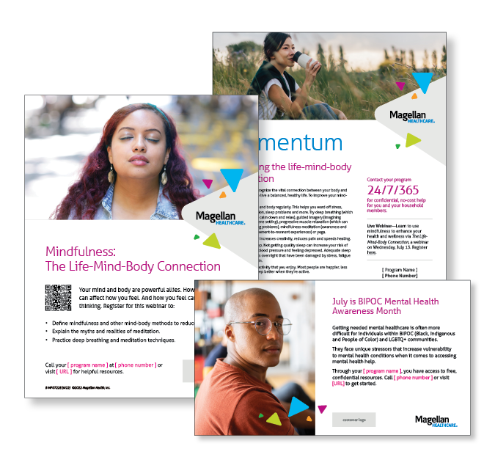**Monthly Theme – Employees**

**Improving the life-mind-body connection**

It’s important to recognize the vital connection between your body and mind if you want to live a balanced, healthy life. Learn how to improve your mind-body health in this month’s newsletter.

**Monthly Webinar – Employees**

**The Life-Mind-Body Connection | July 13**

Join this webinar to:

* Define mindfulness and other mind-body methods to reduce stress.
* Explain the myths and realities of meditation.
* Practice deep breathing and meditation techniques.

[**Register here**](http://magellanhealth.adobeconnect.com/e8w6cnjl2h2a/event/registration.html)

**Financial Wellness Monthly Webinars**

**Balancing Your Financial & Emotional Wellbeing | July 12**

Register here: [9 am PT](https://mysecureadvantage.zoom.us/webinar/register/9016458128021/WN_E7gDPLNFShGQwhMW8SJpFQ) | [12 pm PT](https://mysecureadvantage.zoom.us/webinar/register/2916458143538/WN_vaPUBCgSRSGOtoD_tWT7xg)

Financial stress often goes hand in hand with emotional strains. Review common financial and emotional challenges and get tips for managing them. Also learn how working with professionals can help.

**Investing: Education for Beginners | July 28**

Register here: [9 am PT](https://mysecureadvantage.zoom.us/webinar/register/8816458149867/WN_1YkLOY8oRSayIq4-ptMnZQ) | [12 pm PT](https://mysecureadvantage.zoom.us/webinar/register/8316458158769/WN_kFoXSW9zQTKaaUk3BMAKXA)

Learn how certain investment accounts and timeframes can help you reach your long-term savings goals. Review how mutual funds, stocks, bonds and other investments work. Conclude with practical action steps you can take.