Subject line: Magellan Bulletin - August 2022 Momentum Engagement Campaign and Webinars

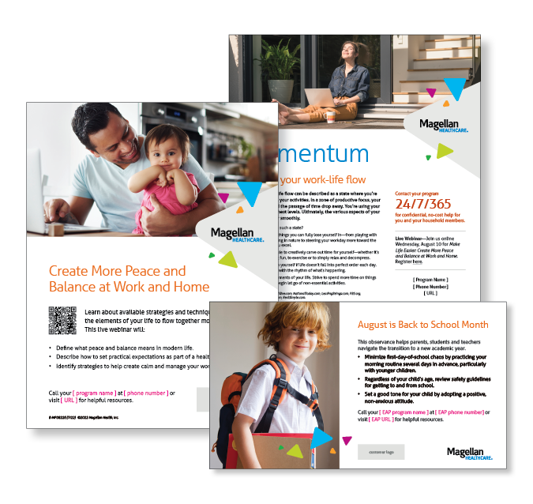

**Monthly Theme – Employees**

**Fueling your work-life flow**

Achieving work-life flow can be described as a state where you’re fully absorbed in your activities. In a zone of productive focus, your ego concerns and the passage of time drop away. You’re using your skills at their highest levels. Ultimately, the various aspects of your life flow together smoothly. How can you reach such a state? Learn more in this month’s newsletter.

**Monthly Webinar – Employees**

**Make Life Easier: Create More Peace and Balance at Work and Home | August 10**

Join this webinar to:

* Define what peace and balance means.
* Describe mindsets and how to set practical expectations.
* Identify strategies to help create calm and manage work-life flow.

**[Register here](http://magellanhealth.adobeconnect.com/ezrpkrm6foeo/event/registration.html)**

**Financial Wellness Monthly Webinars**

**Common Risks to Your Retirement Plan | August 9**

Register here: [9 am PT](https://mysecureadvantage.zoom.us/webinar/register/6816458164467/WN_lTOrDRDXQE62u8o6t7IaBg) | [12 pm PT](https://mysecureadvantage.zoom.us/webinar/register/9416458175613/WN_Z_jbZKI0TqivPRsvVeIYVg)

Although you may be confident in your retirement strategy, sometimes even the best laid plans fall short. We’ll review some retirement risks of which you’ll want to be aware.

**Understanding Medicare | August 25**

Register here: [9 am PT](https://mysecureadvantage.zoom.us/webinar/register/9016458208069/WN_LX7TKwP3Re2SGIQN3mg3cA) | [12 pm PT](https://mysecureadvantage.zoom.us/webinar/register/1316458213229/WN_vMK1h3PUQrO7mChF-br5eg)

With healthcare costs being a large part of everyone’s post-retirement budget, this webinar reviews how your out-of-pocket expenses could go up or down depending on when you retire and start receiving Medicare benefits.