Subject line: Magellan Bulletin - October 2022 Momentum Engagement Campaign and Webinars

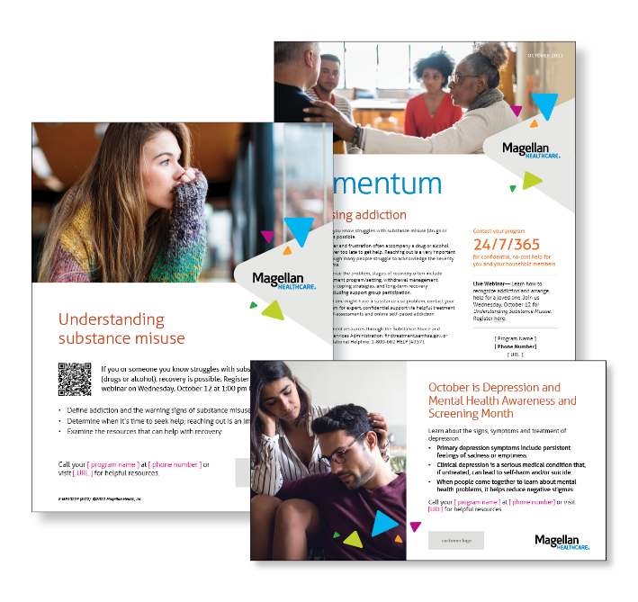

**Monthly Theme – Employees**

**Addressing addiction**

If you suspect that you have a problem with the use of substances (typically drugs or alcohol), it’s vital that you access experienced, credentialed addiction providers who can steer you onto the rewarding road to recovery. Learn more in this month’s newsletter.

**Monthly Webinar – Employees**

**Understanding Substance Misuse | October 12**

Join this webinar to:

* Define addiction and warning signs of substance misuse.
* Identify when it’s time to get help.
* List resources to help with recovery.

**[Register here](http://magellanhealth.adobeconnect.com/e9lp8bof2d5r/event/registration.html)**

**Financial Wellness Monthly Webinars**

**Choosing Your Benefits: What to Fund and Why? | Thursday, October 11**

Register here: [9 am PT](https://mysecureadvantage.zoom.us/webinar/register/6416474462867/WN_PnCQ23KrRpKfCAZDo1BzFw) | [12 pm PT](https://mysecureadvantage.zoom.us/webinar/register/6716474472587/WN_G9wptNDYQVip88XDK9CKFQ)

Learn how Health Savings Accounts, Flexible Spending Accounts and employer-sponsored retirement plans work, and the advantages they can provide to you.

**Estate Planning: Financial Basics | Thursday, October 27**

Register here: [9 am PT](https://mysecureadvantage.zoom.us/webinar/register/3316474476409/WN_aw07UtAdS6mbcw2hMlgyUQ) | [12 pm PT](https://mysecureadvantage.zoom.us/webinar/register/9816474487725/WN_WaCbHFbVSA23JrV-Wt6pdA)

Review how and when to begin your estate planning. Examine the pros and cons of hiring an attorney versus doing most of the work yourself.