Subject line: Magellan Bulletin - November 2022 Momentum Engagement Campaign and Webinars

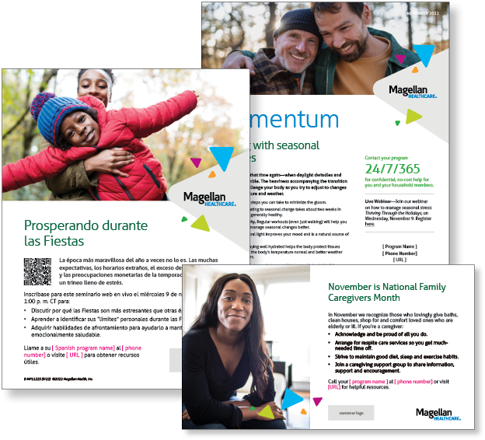**Monthly Theme – Employees**

**Coping with seasonal changes**

It’s getting to be that time again—when daylight dwindles and temperatures tumble. The heaviness accompanying the transition to winter can challenge your body as you try to adjust to changes in light, temperature and weather. Learn more in this month’s newsletter.

**Monthly Webinar – Employees**

**Thriving Through the Holidays | November 9**

Join this webinar to:

* Describe why holidays are more stressful than other times of the year.
* Identify your “limits” during the holidays.
* Explain coping skills to help you stay emotionally healthy.

**[Register here](http://magellanhealth.adobeconnect.com/epir1drv4plt/event/registration.html)**

**Financial Wellness Monthly Webinars**

**How to Navigate Your Finances While Caregiving | November 8**

Register here: [9 am PT](https://mysecureadvantage.zoom.us/webinar/register/5716474493126/WN_YMKQk1xASDiIfu_mhIeB4Q) | [12 pm PT](https://mysecureadvantage.zoom.us/webinar/register/1616474497265/WN_BAZrM3KGTZebKMD5J0ZYFQ)

Caregiving can be a labor of love. At the same time, it can be overwhelming and challenging. This presentation covers different care scenarios and their associated budgeting, healthcare, and estate planning implications. We will discuss the importance of optimally sourcing funds to cover current caregiving expenses, while still allowing the caregiver(s) to fund their own long-term goals.