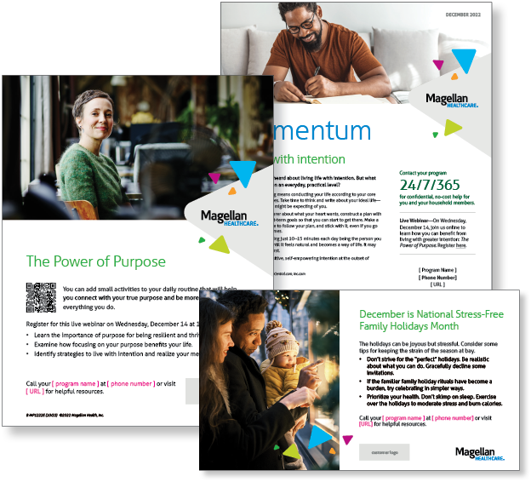
Monthly Theme – Employees
Living with intention
You’ve probably heard about living life with intention. But what does that mean on an everyday, practical level? Intentional living means conducting your life according to your core beliefs and values. Take time to think and write about your ideal life—not what others might be expecting of you. Learn more in this month’s newsletter.

Monthly Webinar – Employees
The Power of Purpose | December 14
Join this webinar to:
- Describe the importance of purpose for resilience
- and thriving.
- Discuss benefits of purpose.
- Identify strategies to live with intention and realize your meaning.
Register here

Monthly Theme – Managers
Bringing out the best in your team
If you’re looking for ways to help your staff members perform at their best, consider using some tried-and-true management practices. Impart clear goals. If you expect optimal productivity from team members, make sure they understand their performance targets in detail. Learn more in this month’s newsletter.

Monthly Webinar – Managers
Leading with Purpose | December 7
Join this webinar to:
- Describe the importance of purpose for leading resilient teams.
- Discuss benefits of leading with purpose.
- Identify strategies to lead with intention.
Register here

Financial Wellbeing Monthly Webinar
Identity Theft: Prevention, Protection & Resolution | December 13
Register here: 9 am PT | 12 pm PT
This class is designed to help you understand how personal data gets compromised, what you can do to prevent it, and the initial steps to take if you become a victim. Identity theft is always evolving, so you’ll benefit from this up-to-date overview.
How can you use these in your workplace?
- Email it to your workforce
- Post it on your Organization’s Benefits Intranet
- Print and post in lunch or break rooms

More Information Available Online!
Looking for more information? There is a whole library of content waiting for you at Member.MagellanHealthcare.com

