Subject Line: Magellan Bulletin – January 2023 Momentum Engagement Campaign and Webinars
The email content is below.
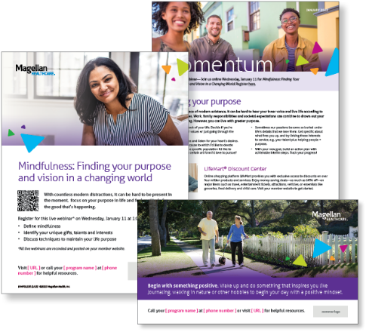
Monthly Theme – Employees
Finding your purpose
Amidst the fast pace of modern existence, it can be hard to hear your inner voice and live life according to your unique values. Work, family responsibilities and societal expectations can combine to drown out your search for meaning. However, you can live with greater purpose. Learn more in this month’s newsletter.

Monthly Webinar – Employees
Mindfulness: Finding Your Purpose and Vision in a Changing World | January 11
Join this webinar to:
- Define mindfulness
- Identify your unique gifts, talents and interests
- Discuss techniques to maintain your life purpose
Register here

Financial Wellbeing Monthly Webinars
New Year...New You! Financial Resolutions You Can Keep! | January 10
Register here: 9 am PT | 12 pm PT
When January arrives, many of us want to start a new financial habit or break a bad one. The real challenge isn’t getting started but sticking to the plan. As a financial coaching organization, we have worked with thousands of people to help them stick to their New Year’s resolutions. We will share tips for setting realistic goals and making it to the finish line.

Your Debt-Free Game Plan | January 26
Register here: 9 am PT | 12 pm PT
Debt is one of the biggest obstacles keeping Americans from reaching their financial goals. This class will encourage you to prioritize debt management, but it doesn’t stop there! We’ll also go over specific debt reduction strategies and review how to write and follow SMART goals. We hope you leave this class motivated and more confident about reducing your debt.

