Subject Line: Magellan Bulletin – April 2023 Momentum Engagement Campaign and Webinars
Email content is below.

Monthly Theme
Financial wellbeing
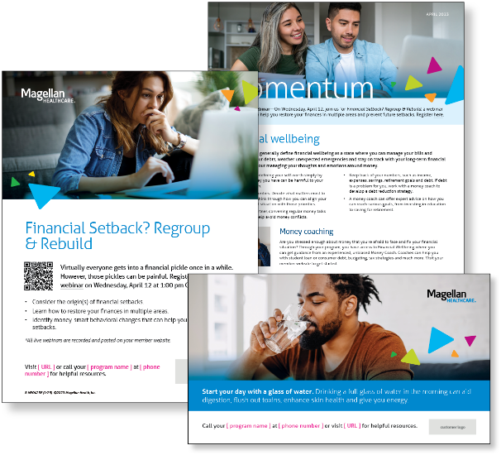
Financial experts generally define financial wellbeing as a state where you can manage your bills and expenses, pay your debts, weather unexpected emergencies and stay on track with your long-term financial goals. It’s also about managing your thoughts and emotions around money. Learn more in this month’s newsletter.

Monthly Webinar
Financial Setback? Regroup & Rebuild | April 12
Join this webinar to:
- Assess where the financial setback occurs (income or expenses)
- Rebuild your finances in multiple areas
- Practice steps to address behavioral changes and prevent future setbacks
Register here

Financial Wellbeing Monthly Webinars
The Financial Wellness Playbook | April 11
Register here: 9 am PT | 12 pm PT
Learn from those who have gone before you! This class shares the habits commonly practiced by people who have little financial stress in their lives. The MSA coaching staff has conducted over a million financial consultations, and the most experienced coaches were interviewed to develop this presentation. The goal is for attendees to take pride in the processes they are practicing well, and to develop an action plan to address the habits they would like to improve.

Investing: Education for Beginners | April 27th
Register here: 9 am PT | 12 pm PT
Learn about the ways that investment accounts might be used to achieve various personal savings goals.
We’ll also talk about the relationship between risk and timeframes. Then, build your knowledge as we explain how mutual funds, stocks, bonds, and other types of investments work. We’ll conclude with some action steps attendees can take to apply what they have learned.

