Subject Line: Magellan Bulletin – February 2023 Momentum Engagement Campaign and Webinars
The email content is below.
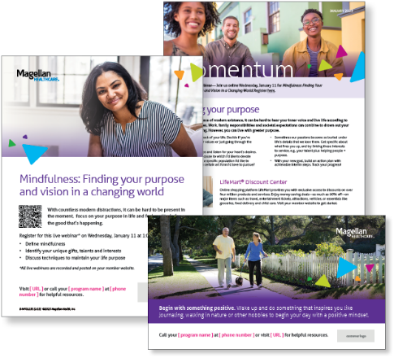
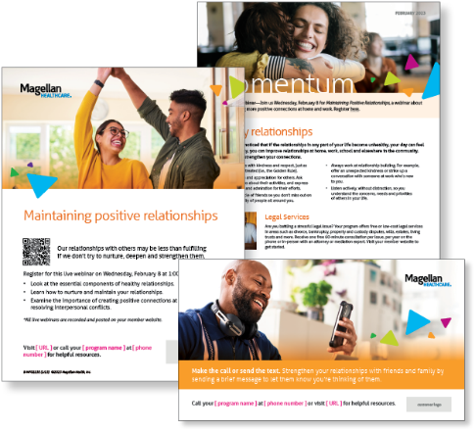
Monthly Theme – Employees
Healthy relationships
You’ve probably noticed that if the relationships in any part of your life become unhealthy, your day can feel tough. Fortunately, you can improve relationships at home, work, school and elsewhere in the community. Try these tips to strengthen your connections.

Monthly Webinar – Employees
Maintaining Positive Relationships | February 8
Join this webinar to:
- Explain healthy relationships
- Identify the components of maintaining positive relationships
- Describe the importance of positive relationships at work and steps to deal with conflict
Register here

Financial Wellbeing Monthly Webinars
Understanding Tax Returns | February 14
Register here: 9 am PT | 12 pm PT
For most taxpayers, tax season usually amounts to “How much is my refund?” or “How much do I owe?” We’ll cover how income tax is calculated, types of adjustments/ deductions, and ways to reduce taxation. We will also review any tax law changes and explore some common mistakes that could be avoided with proper planning.

Retirement Planning: Getting Started | February 23
Register here: 9 am PT | 12 pm PT
Whether you are at the beginning or near the end of your career, the most important first step toward building a retirement plan is creating or establishing a savings goal. Knowing that there are many competing needs or wants for the dollars you save, we will review goal-setting strategies that can help you stay on track. We will also review common types of investment accounts for your savings.

