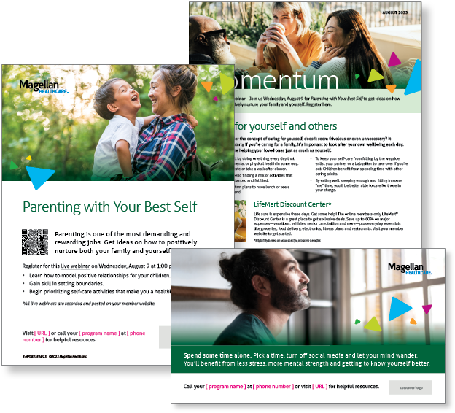**Subject Line:** Magellan Bulletin – August 2023 Momentum Engagement Campaign and Webinars

**Email content is below.**

**Monthly Theme**

**Caring for yourself and others**

When you consider the concept of caring for yourself, does it seem frivolous or even unnecessary? It

shouldn’t. Particularly if you’re caring for a family, it’s important to look after your own wellbeing each day.

By doing so, you’re helping your loved ones just as much as yourself. Learn more in this month’s newsletter.

**Monthly Webinar**

**Parenting with your Best Self | August 9**

Join this webinar to:

* Describe how to model positive relationships
* Learn how to set boundaries
* Identify how to prioritize self-care

[**Register here**](http://magellanhealth.adobeconnect.com/e6g2jdlj3se4/event/registration.html)

**Financial Wellbeing Monthly Webinars**

**Social Security & Your Retirement Plan | August 8**

Register here: [9 am PT](https://mysecureadvantage.zoom.us/webinar/register/7116661178382/WN_jxm_WazVTMiuHZxlKpV54Q) | [12 pm PT](https://mysecureadvantage.zoom.us/webinar/register/6316661174143/WN_ttSn47LWS-OY0S5trg3m0Q)

We contribute to the Social Security system through payroll deductions, but we don’t always know our options for taking those distributions after retirement. This webinar reviews how benefits are calculated and recommends when to start receiving distributions.

**Money Basics: Let’s Build a Plan | August 24**

Register here: [9 am PT](https://mysecureadvantage.zoom.us/webinar/register/9816661188288/WN_v5-xH3ZiRZyz9kQdVduD1g) | [12 pm PT](https://mysecureadvantage.zoom.us/webinar/register/8516661193450/WN_h1WI7K0bQWm7ca9sCoNBGQ)

To feel more confident about your personal finances, adopt a plan that has four components: controlling spending, managing debt, prioritizing savings and maintaining good credit. Learn how to get started and cut your financial stress.