
Subject line: Magellan Bulletin – November 2023 Momentum Engagement Campaign and Webinars

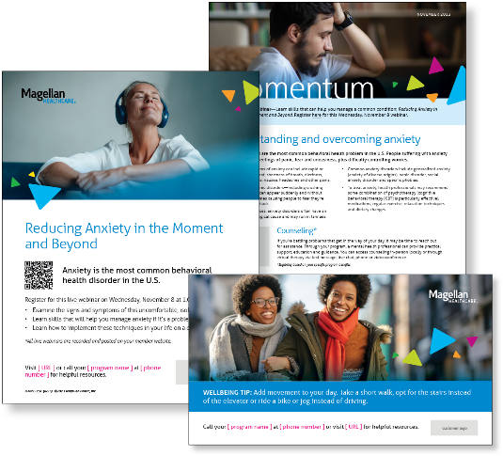
Monthly Theme
Understanding and overcoming anxiety
Anxiety disorders are the most common behavioral health problem in the U.S. People suffering with anxiety may experience feelings of panic, fear and uneasiness, plus difficulty controlling excessive and unrealistic worries. Treatment is available and effective, however. Learn more in this month’s newsletter.

Monthly Webinar
Reducing Anxiety in the Moment and Beyond | November 8
Join this webinar to:
- Define signs and symptoms of anxiety
- Identify skills you can develop to manage anxiety
- Describe how to implement these techniques on a day-to-day basis
Register here

Financial Wellbeing Monthly Webinar
Navigating Finances as a Caregiver | November 14
Register here: 9 am PT | 12 pm PT
Caregiving can be a labor of love. At the same time, it can be overwhelming and challenging. This presentation covers different care scenarios and their associated budgeting, healthcare, and estate planning implications. We will discuss the importance of covering caregiving expenses while balancing a caregiver’s need to fund their own goals.

