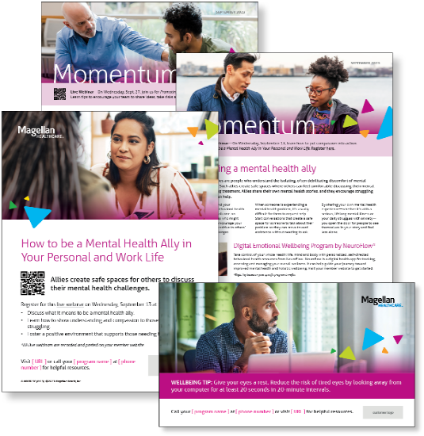
Subject line: Magellan Bulletin – October 2023 Momentum Engagement Campaign and Webinars

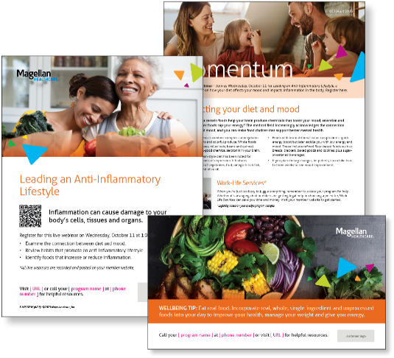
Monthly Theme
Connecting your diet and mood
Did you know that certain foods help your brain produce chemicals that boost your mood, attention and focus — while other foods sap your energy? The medical field increasingly acknowledges the connection between food and mood, and you can make food choices that support better mental health. Learn more in this month’s newsletter.

Monthly Webinar
Leading an Anti-Inflammatory Lifestyle | October 11
Join this webinar to:
- Examine the connection between diet and mood
- Define habits that promote an anti-inflammatory lifestyle
- List foods that impact inflammation
Register here

Financial Wellbeing Monthly Webinars
Understanding Medicare | October 10
Register here: 9 am PT | 12 pm PT
Health care costs are typically one of the biggest expenses in our budget. The Medicare federal health insurance program can help to cover some expenses for those over 65 or for certain younger people with disabilities. But what if we want to retire before age 65 or have access to an employer-sponsored health care plan after 65? This class will review how your out-of-pocket expenses may go up or down depending on when you retire and start receiving your Medicare benefits.

Estate Planning: Financial Basics | October 26
Register here: 9 am PT | 12 pm PT
Many of us know we should have an estate plan, but we don’t know how or when to get started. We will discuss the common components of an estate plan and explain how your plan may change as you go through different stages of life. Lastly, we will cover the pros and cons of hiring an attorney, versus doing most of the work yourself.

