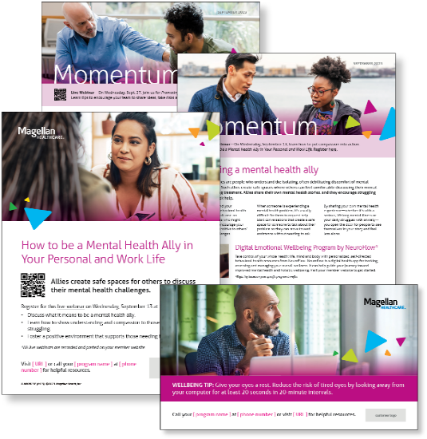
Subject line: Magellan Bulletin – September 2023 Momentum Engagement Campaign and Webinars

Monthly Theme – Employees & Managers
Becoming a mental health ally
Mental health allies are people who understand the isolating, often debilitating discomfort of mental health problems. Such allies create safe spaces where others can feel comfortable discussing their mental states and seeking treatment. Allies share their own mental health stories, and they encourage struggling individuals to seek help. Learn more in this month’s newsletters.

Monthly Webinar – Employees
How to be a Mental Health Ally in Your Personal and Work Life | September 13
Join this webinar to:
- Define what it means to be a mental health ally
- Learn how to help someone who is struggling
- Discuss how to foster a positive environment
Register here

Monthly Webinar – Managers
Promoting Psychological Safety in the Workplace | September 27
Join this webinar to:
- Explain how to build psychological safety
- Review how a safe space improves employee wellbeing
- Summarize best practices for a positive work culture
Register here

Financial Wellbeing Monthly Webinars
Planning for College 101 | September 12
Register here: 9 am PT | 12 pm PT
The costs of attending college continue to increase, so planning is imperative. This class will discuss different types of college savings accounts and review the financial aid process. It may be important to get funds from as many sources as possible, so we’ll review scholarships, grants and loans. Get ready to leave this class better prepared to establish and fund your college savings goals.

Choosing Your Benefits: What to Fund & Why? | September 28
Register here: 9 am PT | 12 pm PT
Many of us wonder which employee benefits are best for us and how much money we should be allocating to them. This class looks at the big picture of employer benefits and how to consider which options are right for you and your family. Learn more about how they work and the advantages they can provide, so that you can feel better equipped to make your benefit choices.

