Subject line: Magellan Bulletin – December 2023 Momentum Engagement Campaign and Webinars

Monthly Theme – Employees & Managers
Emotional wellbeing
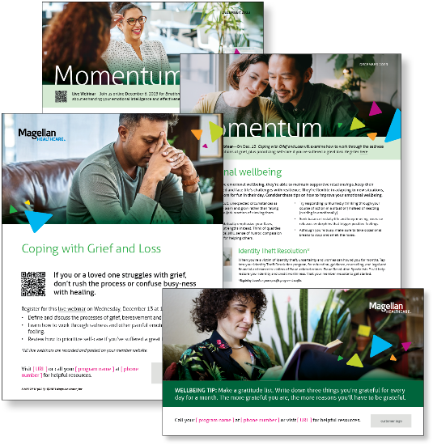
When people have emotional wellbeing, they’re able to maintain supportive relationships, keep their emotions balanced and face life’s challenges with resilience. They’re flexible in adapting to new situations, and they make room for fun in their day. Learn more in this month’s newsletters.

Monthly Webinar – Employees
Coping with Grief and Loss | December 13
Join this webinar to:
- Define grief, bereavement and mourning
- Describe the experience of grief
- Identify how to care for yourself as you grieve
Register here

Monthly Webinar – Managers
Emotional Wellbeing for Leaders | December 6
Join this webinar to:
- Understand the importance of emotional wellbeing to leaders and employees
- List strategies to enhance your wellbeing
- Describe ways to be a more effective leader
Register here

Financial Wellbeing Monthly Webinar
Financial Forum | December 12
Register here: 9 am PT | 12 pm PT
Finances are vital for all of us, so we are dedicating this live forum to answering questions on any financial topic. Our panelists will be ready to talk about issues ranging from credit, saving for emergencies, retirement, student loans, college, and more. If you have a particular question in mind, you can provide it when you register for this event. The more, the merrier, so please encourage any co-workers with financial questions to attend as well.

